Create project

* Create a board like scrum or agile
* Azure Repos
* Git workflows

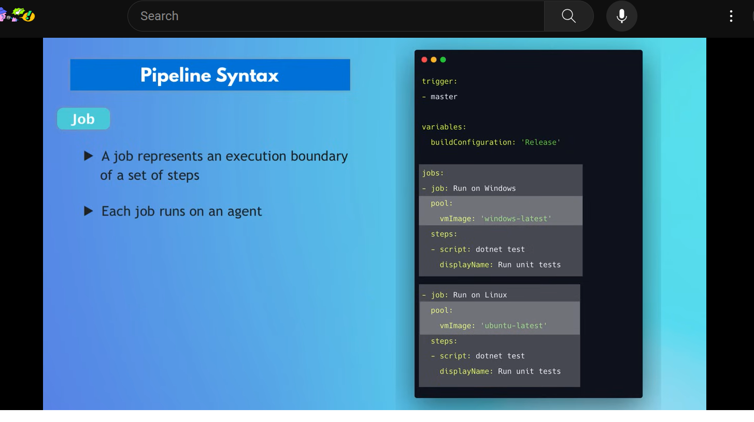

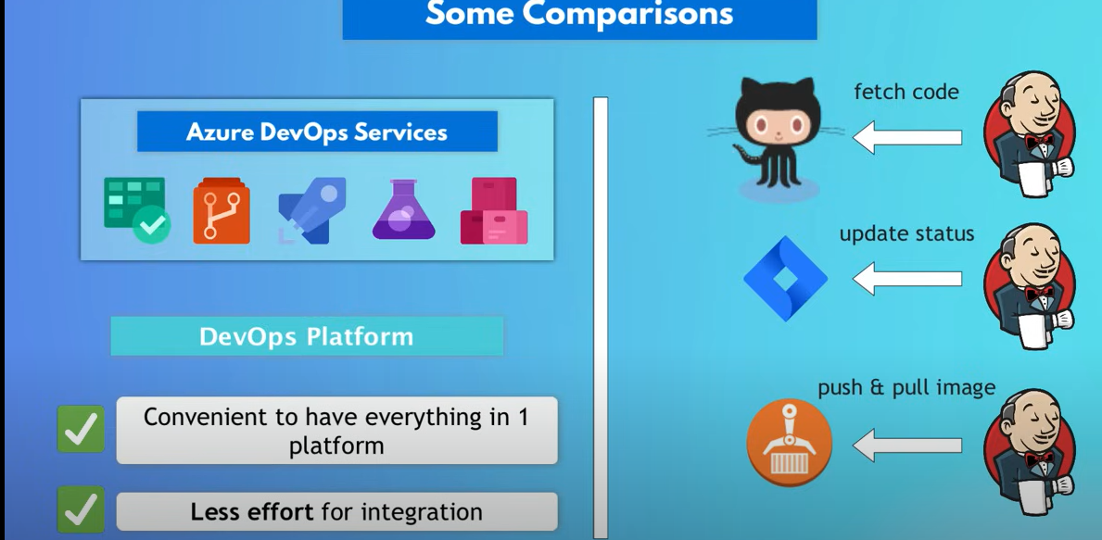

Date: 16/12/23

Azure Devops:

In Azure devops let’s start with creating Agile project

* Once you login to the azure devops portal
* Create a Agile project( here we have options to create type of project(**work item process**) we want to create like Agile/Scrum/CMMI/basic )
* After that you can create azure board
* After that you can create epic under azure board
* Under epic you can create User Stories US
* Under US you can create Tasks
* This the hirearchy Organization > Project(agile) > Azure board > Epic > US > Tasks
* And creating sprints and adding required backlog task to the sprint
* All these you can see dashboard(kanban dashboard)

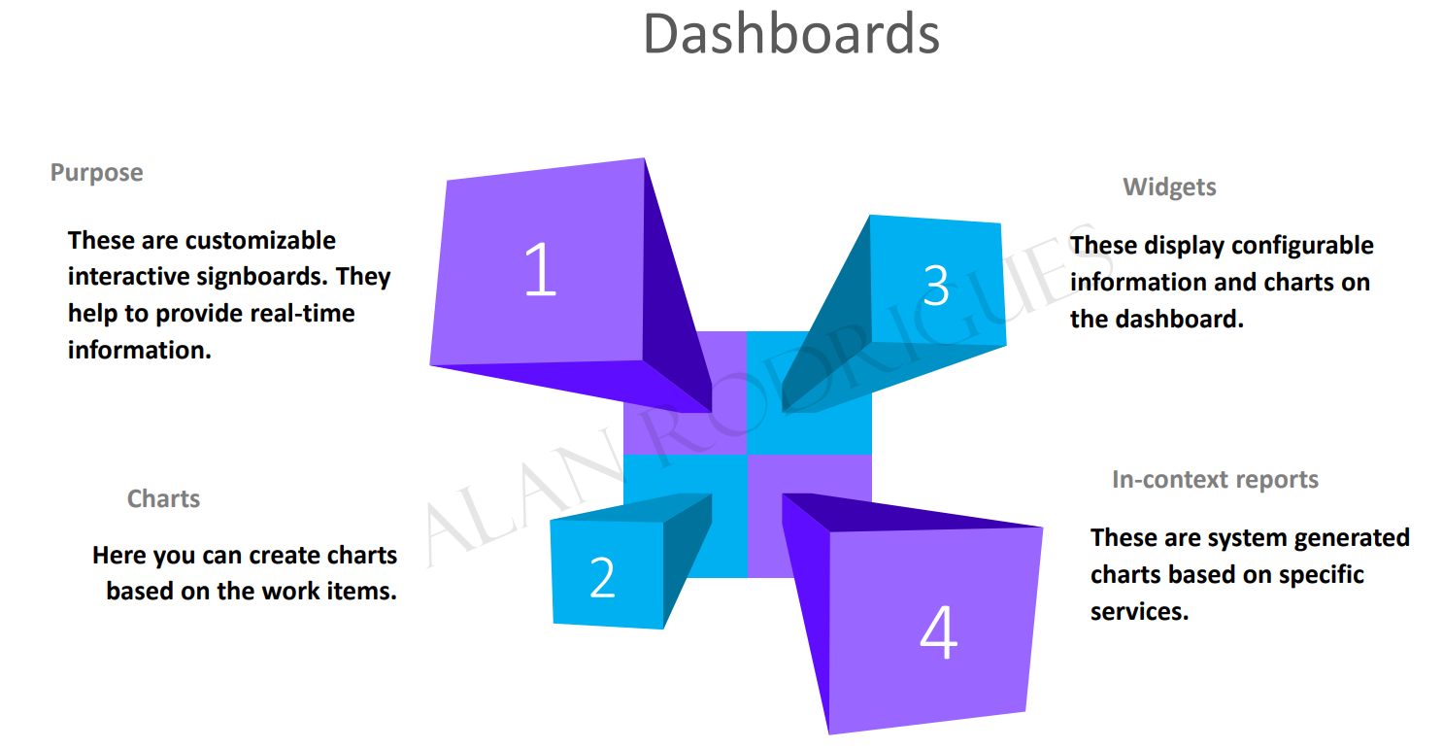

* We can assign users to the tasks

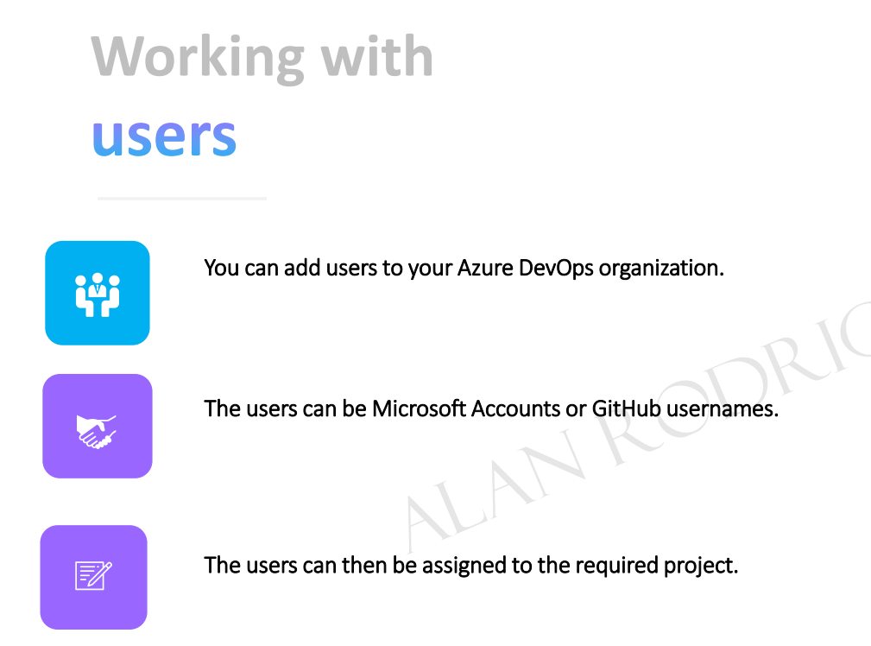

* We have permissions assigned to users by adding them to security groups like “contributer/build administrators/ project administrators/ project valid users/ readers/ release administrators”(permissions can be assigned at organization/project/object level)
* 